# Rapid Appraisal of Riparian Condition Methodology Guide

*1. Introduction*

The vegetation along a waterway is called riparian vegetation. It is a key contributor to waterway health, acting as a buffer between the waterway and adjacent lands. A well vegetated riparian zone can improve water quality by filtering overland flow and can reduce erosion along creek banks. Shady trees protect vulnerable organisms from extremes of temperature; root systems and woody debris become habitat for fauna and organic matter sustains aquatic food webs. Furthermore, riparian vegetation may act as habitat and also as a corridor linking fragmented faunal habitats. It adds to a waterway’s aesthetic and recreational value and can act as a screen between incompatible land uses. Given this background, any appraisal of waterway condition must incorporate an assessment of riparian vegetation.

The methodology presented here is based on existing rapid riparian vegetation assessment methods and additional expert knowledge. The aim is to capture physical data including riparian vegetation community structure and floristics. It describes the width, length, cover and other physical parameters. The overall assumption is the wider the riparian zone, the denser the canopy cover and the greater the proportion of waterway shaded – the better the health of the waterway.

*2. Data Collection*

2.1 Site Assessment Procedure

Site selection should be undertaken before the site assessment visit if possible. This can be done using a desktop review of aerial photos or satellite imagery (such as NearMap). This tool is especially useful in determining the position of transects and their corresponding continuities, and assists in making sure the chosen areas are representative of the reach.

Upon arrival, the full length of the riparian zone undergoing assessment should be walked to become acquainted with features, vegetation, natural variation, and dimensions prior to data collection. A 50 metre transect can then be laid out parallel to the stream within the riparian vegetation before assessment begins. It is recommended to perform this appraisal yearly or twice yearly for each catchment site.

2.2 Use of the Field Sheet

This field sheet contains the following fields:

* General Information for site identification
* Diagrams
* Longitudinal Continuity of Riparian Canopy Vegetation
* Channel and Riparian Vegetation Width
* Contiguous and adjacent terrestrial vegetation
* Canopy Cover
* Shrub Cover
* Ground Cover
* Fallen Timber and Dead Standing Trees
* Recruitment of Native Canopy Species
* Vegetation/foliage Cover Over Waterway
* **Sum of Ecological Values Scores**
* Disturbance
* **Sum of Disturbance Scores**
* Fauna/Habitat Values
* Other Biodiversity Values
* Site Connectivity
* Rehabilitation Required?
* Species Description (Optional)

The field sheet results in two separate scores: one total score for Ecological Values, and one total score for Disturbance. Guidelines for scoring are provided on the data sheet and reproduced in the following paragraphs.

***General Information for site identification***

These fields allow for collection of site-specific basic information that does not rely upon in-depth investigation of the site. The fields are as follows:

*Site*

The site name should correspond exactly with the name found on project documentation.

*Transect Number*

Sites may need multiple transects performed to obtain better representation of the entire site. The transect number is therefore recorded here and should be consistent across years.

*Location of transect*

This should also correspond with other project documentation.

*Date*

Record the date of the assessment.

*Time*

Record the approximate start time of the assessment.

*Observers*

The person(s) recording the data record their name(s) in full and not abbreviated, for future use. Write the name of the person recording the data first, before listing others directly involved.

*GPS Datum*

Specify the GPS reference system used. This datum will most likely be GDA94 as this supersedes AGD84 in Australia. GDA94 and WGS84 are considered the same system in this context.

*GPS Beginning and End/ Accuracy*

Record the eastings and northings corresponding with the beginning and end of the reach assessed using a handheld (or other) GPS (Global Positioning System) unit. Please ensure such coordinates are in decimal degrees (not in degrees, minutes and seconds). For example, 27° 30' 21.024'' N, 153° 2' 29.076'' E would be 27.50584N, 153.04141S.

*Photo*

If possible, take a photo at each start and end GPS point for each transect, looking along the transect. Also, take a photo facing upstream, downstream and across the channel to the opposite bank. Record the name of the person who took the photo. Such photos should be uploaded onto a computer and placed in a clearly marked folder of sites assessed, using a consistent photo description/number.

*Regional Ecosystem Framework Number*

#### Use the map request service at [https://www.qld.gov.au/environment/plants-animals/ biodiversity](https://www.qld.gov.au/environment/plants-animals/%20biodiversity) to request a map showing the pre-clearing Regional Ecosystem Number. If the vegetation is not actually remnant but rather regrowth or plantings, write “non-remnant”. It may be necessary to use Google Earth’s add-on vegetation mapping function to clearly identify the right number.

***Diagrams***

Diagrams should be drawn as they are a useful descriptor of the site and allows for observers to gain a greater understanding of site components.

Vegetation Layer Diagram: Please draw how the vegetation layers are structured. This should include whether there is a shrub layer, sub-canopy layer, canopy layer, and emergent layer. Also record estimations of the height ranges of each layer.

General Site Layout Diagram: Draw an overview of the entire transect using an aerial view approach. This should include the position of the transect, stream, contiguous vegetation, adjacent vegetation patches, pathways, roads and any other components of the site you deem important. Please revisit this diagram as measurements are made throughout the data sheet, particularly in regards to channel width and vegetation width.

***Longitudinal Continuity of Riparian Canopy Vegetation***

A 150m transect should be created, adding 50m to either side of your survey transect (see Figure 1). The entire 150m is then walked to measure gaps. This is done as follows:

* Identify, measure, and record each length of canopy gap along the 150m transect. Canopy gaps in this methodology are defined as any breaks observed between trees that are taller than the shrub layer, estimated by looking directly upwards
* A tree is defined by the QLD Government as a woody plant over 2m, provided it has a single stem.
* To calculate Total Length of Canopy Gap, add all the lengths of the canopy gaps.
* To calculate Total Vegetated Length, subtract Total Length of Canopy Gap from 150m. Express this as a percentage.
* Count and record the number of Canopy Gap Lengths over 25m.
* To calculate the overall score, use the following scheme:
  + Vegetated Length of less than 50% = Score of 0
  + Vegetated Length of between 50-64% = Score of 1
  + Vegetated Length of between 65-79% = Score of 2
  + Vegetated Length of between 80-94% = Score of 3
  + Vegetated Length of 95% and greater = Score of 4
* 0.5 must be taken off the score for each Canopy Gap Length greater than 25m
* Refer to Table 1 for an example calculation of scoring.

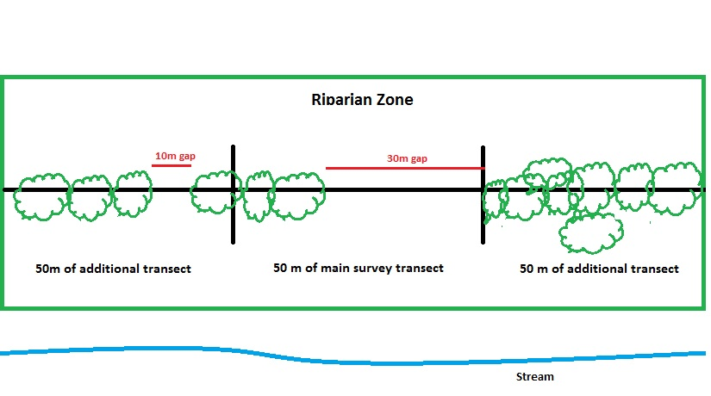Figure 1: A diagram of the Riparian Zone to show how Longitudinal Continuity is measured.

Table 1: An example calculation for scoring Longitudinal Continuity, using Figure 1 as an example of gap measurements.

|  |  |  |  |  |
| --- | --- | --- | --- | --- |
| Length of each break/gap in canopy tree layer along 150m length | Total length of canopy gaps | Total vegetated length  (150m – total canopy gaps) | No. of canopy gaps  **≥**25m long | Score |
| **10 + 30** | __**40**_ m / 150m | 150 – _**40**_ m = _**110**_ m vegetated  **110** m vegetated x 100= _73_% vegetated  150 | **1** | **2 – 0.5**  **= 1.5** |

***Channel and Riparian Vegetation Width***

Record the Channel Width and Riparian Vegetation Width at 0m, 25m and 50m along the transect (see Figure 2), as follows:

* *Channel Width* is from high bank to high bank, measured with a tape measure or visual estimation. This is not a measurement of water present in the stream (known as Stream Width). The three measurements taken must then be averaged, however, no score is recorded for Channel Width.
* *Riparian Vegetation*Riparian vegetation in this methodology refers to vegetation adjacent to a creek, which floods (including in high-flow). Local knowledge may be needed for this section. As riparian vegetation includes vegetation that is both in the channel (eg on a low bank) and out of the channel, two measurements must be taken (even though it is only ‘out of channel’ vegetation that is scored):
  + In channel vegetation: This measurement is taken from the waters edge to the top of the high bank at 90 degrees from the transect line.
  + Out of channel vegetation: This measurement is taken from the top of the high bank (where in channel vegetation ends) to where riparian vegetation ends, at 90 degrees from the transect line.
* Please note: vegetation that is well above flood level is called Terrestrial Vegetation and is measured as part of “Contiguous Terrestrial” in the next section on the field sheet.
* For Riparian Vegetation Width, three measurements are again taken: at 0m, 25m, and 50m, for both in channel and out of channel vegetation. This is then averaged, and given a score as follows:
* **For a Channel < 10 m wide:** 
  + Less than 5m is vegetated = Score of 0
  + Between 5-9m is vegetated = Score of 1
  + Between 10-29m is vegetated = Score of 2
  + Between 30-39m is vegetated = Score of 3
  + Greater than or equal to 40m Vegetated = Score of 4
  + *So if a channel is 9 m wide and has a 25m wide strip of vegetation, it would get a score of 2.*
* **For a Channel ≥10 m wide:** 
  + Proportion is less than 0.5 = Score of 0
  + Proportion is between 0.5 – 0.9 = Score of 1
  + Proportion is between >0.9 – 2.9 = Score of 2
  + Proportion is between >2.9 – 3.9 = Score of 3
  + Proportion is equal or greater than 4 = Score of 4
  + *For channels 10m wide or greater, the score depends on both Out-of-Channel Vegetation Width and Channel Width. Work out the proportion of Out-of-Channel Vegetation Width to Channel Width (VW/CW). For example, 15 m of out-of-channel vegetation width with a 10 m channel width would be 1.5 (15/10=1.5). This would get a score of 2.*

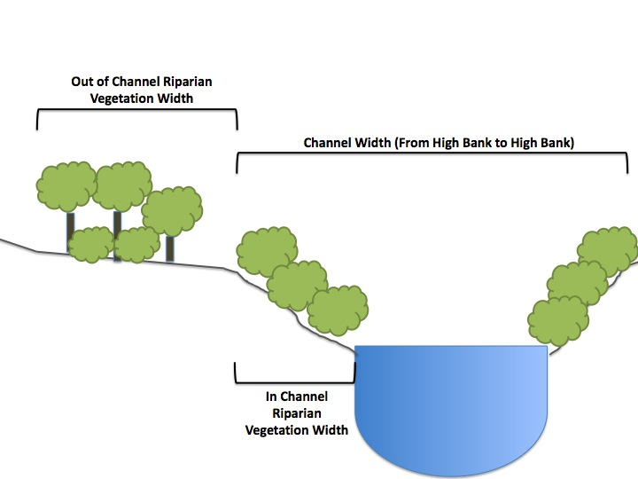

Figure 2: Diagram depicting the definitions for Channel Width, and in- and out-of-channel Riparian vegetation width used within this methodology.

***Contiguous and Adjacent Terrestrial Vegetation Width***

This section is used to record the width of contiguous vegetation, and whether there is the presence of adjacent terrestrial vegetation nearby.

*Contiguous Vegetation* is terrestrial non-riparian vegetation (i.e – it does not flood) and only includes vegetation directly connected with the riparian vegetation (which was measured earlier in this methodology). Please note that in many urbanised catchments this may be absent. If this is too difficult to measure in the field due to steep terrain or property boundaries, it can be measured using aerial maps (such as NearMap) in the office at a later time.

* Contiguous Terrestrial Vegetation is scored as follows:
  + 0m of Contiguous Vegetation = Score of 0
  + Between 10-25m of Contiguous Vegetation = Score of 1
  + Between 26-50m of Contiguous Vegetation = Score of 2
  + Contiguous Vegetation greater than 50m = Score of 3

*Adjacent terrestrial vegetation* is any terrestrial vegetation nearby to the transect (on the same side of the creek the transect is on), but separated from the riparian vegetation. For example, there may be mown grass or a pathway separating these two types of vegetation (and therefore is not contiguous). If there is the presence of adjacent terrestrial vegetation and it is closer than 20 metres from the riparian vegetation edge (using a measuring tape), then this is given a score of 1. This is due to recognition that, although not connected with the riparian vegetation, native fauna may still traverse this small gap and utilise the surrounding vegetation. It is scored as follows:

* + Presence of adjacent vegetation within 20m of riparian vegetation edge = Score of 1
  + Absence of adjacent vegetation within 20m of riparian vegetation edge = Score of 0

***Canopy Cover***

This section records the vegetation cover of the major vegetation strata in the riparian zone. The Total Canopy Cover is an estimation of the vegetation cover over 2m tall (whether native or exotic) and is expressed as a percentage. For example, looking vertically toward the canopy, if 60% of the sky is visible, then the cover is 40%. All assessments are done three times along the transect: at 0m, 25m, and 50m. Refer to Appendix C for a useful visual aid for estimating Canopy Cover. It may be useful to take a photograph pointed directly upwards from the transect line and use this as a guide. If possible, split Total Canopy Cover into exotic and native percentages. For example, if total vegetation cover is 60%, native cover might be 30% and exotic cover might be 30% (adding up to the total 60% cover). Canopy Cover is scored as follows:

* + 0 Canopy Cover = Score of 0
  + 1-10% Canopy Cover = Score of 2
  + 11-49% Canopy Cover = Score of 4
  + ≥ 50% Canopy Cover = Score of 5

***Shrub Cover***

This section records total shrub cover at 0m, 25m and 50m along the transect. This is done by estimating total shrub cover within a 5 x 5 metre square, centred around the point in question along the transect. Please note, shrubs are woody plants that are either multistemmed from the base (or within 20 cm of ground level), or single stemmed but less than 2 metres tall (refer to Appendix B for typical Shrub life-forms). This does not include recruitment of species that will become trees. Estimates are then averaged to allow for scoring.

The scoring is as follow:

* + 0 shrub cover = Score of 0
  + 1-10% shrub cover = Score of 2
  + 11-29% shrub Cover = Score of 4
  + ≥ 30% shrub Cover = Score of 5

***Ground Cover***

This section records ground cover by using five 1 x 1 metre quadrats placed along the 50m transect.

* One quadrat should be used within every 10m of transect. For example, a quadrat should be randomly placed at least 1m away (and no further than 5m away) from the transect line, between 0-10m, 10-20m, 20-30m, 30-40m, and 40-50m, and alternating sides each time.
* For each quadrat, a percentage of Native Ground Cover, Exotic Ground Cover, Leaf Litter and Woody Debris, Rock, and Bare Ground should be estimated. These should add to create a total percentage of 100%. Refer to Appendix B for typical Ground Cover life-forms, which include Grasses, Forbs and Other Species. Ground cover does not include seedling trees.
* If you do not know what percentage is exotic and native, simply estimate a number for total Ground Cover.
* If leaves or stems of groundcover vegetation are over leaf litter, this is scored as groundcover vegetation.
* Do not place the quadrat around trees, shrubs, or exposed tree roots. If tree roots cannot be avoided, consider only the ground in your quadrat not covered by roots, and estimate percentage ground cover vegetation in that area.
* Each category is then averaged, however, the total Ground Cover Score is only calculated using Native and Exotic Ground Cover (summing the two averages).

Ground Cover Vegetation is scored as follows:

* + 0% Ground Cover = Score of 0
  + 1-14% Ground Cover = Score of 2
  + 15-49% = Score of 4
  + Cover greater than or equal to 50% = Score of 5

Leaf Litter and Woody Debris is scored as follows:

* + 0% Cover = Score of 0
  + 1-10% Cover = Score of 2
  + 11-29% Cover = Score of 4
  + Cover greater than or equal to 30% = Score of 5

***Fallen Logs and Dead Standing Trees***

*Fallen Logs* are useful as habitat for insects and vertebrates, and whether there is greater water infiltration into the soil. The number of fallen logs should be counted along the entirety of the 50m transect, including the area from top of bank to the outer riparian vegetation edge. A fallen log is considered as a natural fallen trunk or branch with a diameter greater than 10cm and longer than half a metre. The scoring is as follows:

* + No logs = Score of 0
  + 1-4 logs = Score of 4
  + 5 logs and greater = Score of 5

Please note that “greater than 5 logs” is automatically given the maximum score of 5 and there is no need to keep tallying after this point.

*Standing Dead Trees* can be useful in determining habitat features. Dead trees can also indicate factors contributing to tree death. Therefore, standing dead trees are counted along the entirety of the 50m transect, including the area from top of bank to the outer riparian vegetation edge. Standing dead trees are only counted if they are over 20cm diameter at breast height (DBH). This includes trees that are multi-stemmed, with stems that add up to exceed 20cm in diameter.

The score for Standing Dead Trees is as follows:

* + No standing dead trees = Score of 0
  + 1-4 standing dead trees = Score of 2
  + 5-9 standing dead trees = Score of 4
  + 10 logs and greater = Score of 5

***Recruitment of Native Canopy Species***

Canopy recruitment (ie germination of seedlings of the adult trees present in the canopy) provides an indication of the long-term health of the community, as the mature trees are replacing themselves over time, and it can also indicate a cessation of some land use activities, such as grazing or slashing. Record the presence of native recruitment in only the canopy species (exotic recruitment should not be included in the scoring). Recruitment includes those that have been planted by bushcare groups. A recruit is a seedling or sapling equal to or less than 5cm DBH. If possible, record some of the species names.

Canopy recruitment (regeneration) scoring is as follows:

* + 0 individuals = Score of 0
  + 1-5 individuals = Score of 2
  + 6-10 individuals = Score of 3
  + 11-19 individuals = Score of 4
  + 20 individuals or greater = Score of 5

***Vegetation/foliage Cover Over Waterway***

Vegetation cover over the waterway is useful in shading out weeds and tempering water temperature extremes. This field records the average percentage of foliage cover over water (not shading, which varies with time of day) across the 50m length of creek corresponding to your transect site.

This is scored as follows:

* + 0-5% cover = Score of 0
  + 6-30% cover = Score of 2
  + 31-60% cover = Score of 4
  + Cover greater than or equal to 61% = Score of 5

***Total Sum of Ecological Values Scores***

This section is for the sum of Ecological Values. This score is out of a total of 52, with a higher score indicating a site of higher ecological value.

***Disturbance***

This section is used to record type and severity of disturbance of the riparian zone at each site. Table 2 below lists and defines each disturbance type as per the field sheet.

Table 2: Disturbance Types and Definitions

| **Disturbance Type** | **Definition** |
| --- | --- |
| Storm damage | Includes trees and other vegetation blown over by wind or with leaves stripped. |
| Tree Clearing | Includes evidence of trees being logged selectively and on a small scale. For example, tree stumps may be present from recent Council logging. |
| Grazing | Includes evidence of plant consumption from livestock, possums, wallabies, and kangaroos |
| Extensive recent clearing | Includes evidence of non-selective and extensive clearing for any purpose within the last 2 years. This might include brush-cutting of weeds. |
| Human access Impacts | Includes unauthorised and damaging vehicular entry or through foot crossing. Can also include impacts from domesticated animals (eg – dog faeces) |
| Rubbish/Litter | Anthropogenically-sourced rubbish. |
| Infrastructure | Built structures (e.g. bridge) and the associated construction and access impacts. |
| Fire | From arson or prescribed burns. |
| Weeds | All exotic and non-endemic natives |
| Flow Impacts | Includes deposition of debris or sediment on vegetation from events such as flooding, as well as trees or shrubs clearly knocked over by water flow. Excludes erosion. |
| Erosion | Includes undercutting, slumping or other physical erosive processes. |
| Vines | Native or exotic vines that are physically damaging native plant/ shrubs. |

Severity Ratings are defined as follows:

* + No evidence of impacts. = Score of 0
  + Minor impacts, little disturbance, small areas affected or large areas affected slightly. = Score of 1
  + Moderate impacts, some disturbance, small areas affected badly or large areas affected moderately = Score of 2
  + Severe impacts, major disturbance, large area affected or severe spot impacts affecting a greater area. = Score of 3

***Sum of Disturbance Scores***

This section is for the sum of disturbance scores. This score is out of a total of 36, with a higher score indicating a highly disturbed site.

#### *Fauna/Habitat Values*

This element records details of fauna usage or habitat features. Whilst not necessarily contributing directly to waterway health, fauna and habitat values can be used to assist in determining overall ecological functionality.

Record the presence or absence of potential or actual habitat features observed. These include:

* Tree hollows that could be utilised by birds and small mammals
* Burrows.
* Nests (including termite nests)
* Canopy cover suitable for shelter, perching and/or foraging of species
* Dense ground cover. For example, this might include grassy tussocks
* Flaking bark. This might provide habitat for reptiles and insects
* Rocky outcroppings. These can be utilised by species such as reptiles and small mammals
* Woody debris
* Crevices/caves
* Sedges, reeds and other vegetation directly around the watercourse

***Incidental Fauna Species Recorded***

Record any fauna incidentally observed during the site visit. Include identifications made from scats, signs or tracks where possible. If unsure of identification, leave off or qualify recording.

***Other Biodiversity Values***

Note any site observations that provide insight into its value for the city, such as whether it is an existing tree planting site, or whether there is evidence of previous rehabilitation work.

***Site Connectivity***

Briefly note the connectivity of the site to adjacent bushland and upstream and downstream along the waterway from a fauna movement perspective. The width of contiguous terrestrial vegetation is recorded on page 1 of the Field Sheet.

***Rehabilitation Required?***

Note any potential rehabilitation actions required or recommended. These may include:

* weed removal
* erosion control
* planting
* assisted natural regeneration
* concrete channel
* channel piped
* habitat restoration
* a combination of these.

***Species Distribution***

If able, please record the names of plant species found within the transect area, including both native and exotic species. Particularly identify any predominant species. This might include predominant exotic species that are having a large and negative impact on the site which might require attention. One way to briefly indicate abundance is using the “dafor” rating scale; ie assign a letter d,a,f,o,r to show a species is dominant, abundant, frequent, occasional or rare.

*3. Reporting*

Some data, such as the presence of certain weeds or native fauna, may be important information to disseminate to other groups such as BCC, Atlas of Living Australia or Weedspotters network.

*4. Quality Assurance/Capacity building*

To effectively use the field sheet, groups will find it helpful to develop a reasonable knowledge of the following:

* an understanding of vegetation structure and floristics
* plant identification skills
* limited fauna identification skills
* an understanding of habitat values
* GPS use
* Ability to ‘read’ the ecological context of the site.

*5. Data Interpretation*

Scores are added separately for Ecological Values (maximum score of 52), and Disturbance (maximum score of 36). Overall weightings for each sub-index are shown in Table 3 below.

Fields that record qualitative data do not require scoring. These physical descriptions will be used to confirm the values of waterways where the scoring leads to an inconclusive result.

*6. Use of the spreadsheet*

An Excel spreadsheet was created by Norman Creek Catchment Coordinating Committee in order to keep an electronic record of each transect site, and to allow for useful score calculations, comparisons and graphing. This spreadsheet includes most fields contained on the field sheet, and contains formulas for the calculation of Ecological Values as well as Disturbance Scores. The spreadsheet also consists of a section for “sub-scores”, in order to allow for calculations of specific aspects of the transect, and therefore for a deeper analysis of sites. These are divided into the following categories (which do have some overlaps):

* Connectivity
  + Longitudinal Continuity
  + Width of Riparian Vegetation
  + Contiguous Terrestrial Vegetation
  + Adjacent Terrestrial Vegetation
* Vegetation Cover
  + Canopy Cover
  + Shrub Cover
  + Ground Cover
* Debris
  + Leaf Litter
  + Fallen Timber
* Habitat Features
  + Fallen Timber
  + Leaf Litter
  + Dead Trees

Table 3: Scoring and weightings for each sub-index

|  |  |  |  |
| --- | --- | --- | --- |
| **Sub-index** | Indicator | **Range** | **Total** |
| **Connectivity** | Longitudinal continuity | 0-4 | 12 |
| Riparian vegetation width | 0-4 |
| Contiguous terrestrial vegetation | 0-3 |
| Adjacent Terrestrial vegetation | 1 |
| **Vegetation Cover** | Canopy Cover | 0-5 | 15 |
| Shrub cover | 0-5 |
| Groundcover | 0-5 |
| **Debris** | Leaf Litter and woody debris | 0-5 | 15 |
| Fallen Logs | 0-5 |
| Standing dead trees | 0-5 |
| **Recruitment** | Canopy recruitment | 0-5 | 5 |
| **Cover over waterway** | Cover over waterway | 0-5 | 5 |
| **TOTAL** | **Sum of Ecological Values Scores** |  | **52** |
| **Disturbance** | 12 classes of disturbance, 0 is least-disturbed | 0-3 | 3 |
| **TOTAL** | **Sum of Disturbance Scores** |  | **3****6** |

*6. Background to the Rapid Appraisal of Riparian Condition Methodology*

The data sheet for this project was created using existing data sheets and input from in-house expertise. The base for the data sheet was the *Quaternary Assessment Vegetation Mapping Recording Form* developed by City Design for the BCC Regional Ecosystem mapping project. This quaternary data sheet was itself adapted from the Queensland Herbarium quaternary assessment data sheet. The quaternary level of vegetation assessment is the least comprehensive level used by the Herbarium. It aims to record only enough basic vegetation data to establish the community type. The survey duration is typically around 60 minutes per transect. For this reason, this level of assessment is ideal for the rapid riparian vegetation assessment for this project.

A literature review and web search was conducted to identify other existing procedures or proformas. From this, the Rapid Appraisal of Riparian Condition(RARC), developed for Land and Water Australia by Jansen *et al* (2003), was adopted and adapted, to fulfil the aquatic requirements of the data sheet.

**Revised Riparian Method**

The RARC proforma was developed for and tested along large rural rivers in south-eastern Australian grazing lands. Therefore, the original design reflects the collection of data tailored for river-banks affected by stock. Impacts from grazing were rarely observed in Brisbane, where streams typically feature anthropogenically-sourced impacts, such as weeds, rubbish, erosion, sedimentation and access disturbance. This issue has been addressed by amending the fields to collect more data related to urban waterway issues and less on grazing impacts.

In 2014, the method was adapted slightly to align with Council’s biodiversity assessment vegetation survey methods and data sheets. This resulted in some changes in parameters and scoring that were expected to enable the sharing of riparian survey data across teams

This method was further adapted by Norman Creek Catchment Coordinating Committee in 2017 to create the “Riparian Condition Field Sheet N4C Edit”. Considerable modifications were made to the field sheet and this current version of the accompanying guide. Such adaptations were done with reference to the Queensland Herbarium Biocondition Assessment Manual (Version 2.2, 2015), and is accompanied by an excel document for data recording and analysis.

**Limitations of the RARC survey**

Vegetation patterns or condition can vary considerably over the reach surveyed. Therefore, in some cases, the data collected may not adequately describe the range of actual conditions, as the rapid assessment process tends to ‘average’ vegetation patterns across the site.

**Appendix A:**

**Optional Vegetation Survey Field Sheet**

|  |  |  |  |  |  |
| --- | --- | --- | --- | --- | --- |
| **Site Name:**  **Date:**  **Plant Species** | **Common Name (if needed)** | **Exotic? (*)** | **Strata (G,S,T)** | **Abund-ance (dafor)**  Dominant, Abundant, Frequent, Occasional,  Rare | **Comments** |
|  |  |  |  |  |  |
|  |  |  |  |  |  |
|  |  |  |  |  |  |
|  |  |  |  |  |  |
|  |  |  |  |  |  |
|  |  |  |  |  |  |
|  |  |  |  |  |  |
|  |  |  |  |  |  |
|  |  |  |  |  |  |
|  |  |  |  |  |  |
|  |  |  |  |  |  |
|  |  |  |  |  |  |
|  |  |  |  |  |  |
|  |  |  |  |  |  |
|  |  |  |  |  |  |
|  |  |  |  |  |  |
|  |  |  |  |  |  |
|  |  |  |  |  |  |
|  |  |  |  |  |  |
|  |  |  |  |  |  |
|  |  |  |  |  |  |
|  |  |  |  |  |  |
|  |  |  |  |  |  |
|  |  |  |  |  |  |
|  |  |  |  |  |  |
|  |  |  |  |  |  |
|  |  |  |  |  |  |

**Appendix B**

**Life-form Identification**

Diagrams taken from: Eyre et al (2015) BioCondition: A Condition Assessment Framework for Terrestrial Biodiversity in Queensland. Assessment Manual. Version 2.2. Queensland Herbarium, adopted from Robinson, L. (1991). Field guide to the Native Plants of Sydney. Kangaroo Press, Sydney.

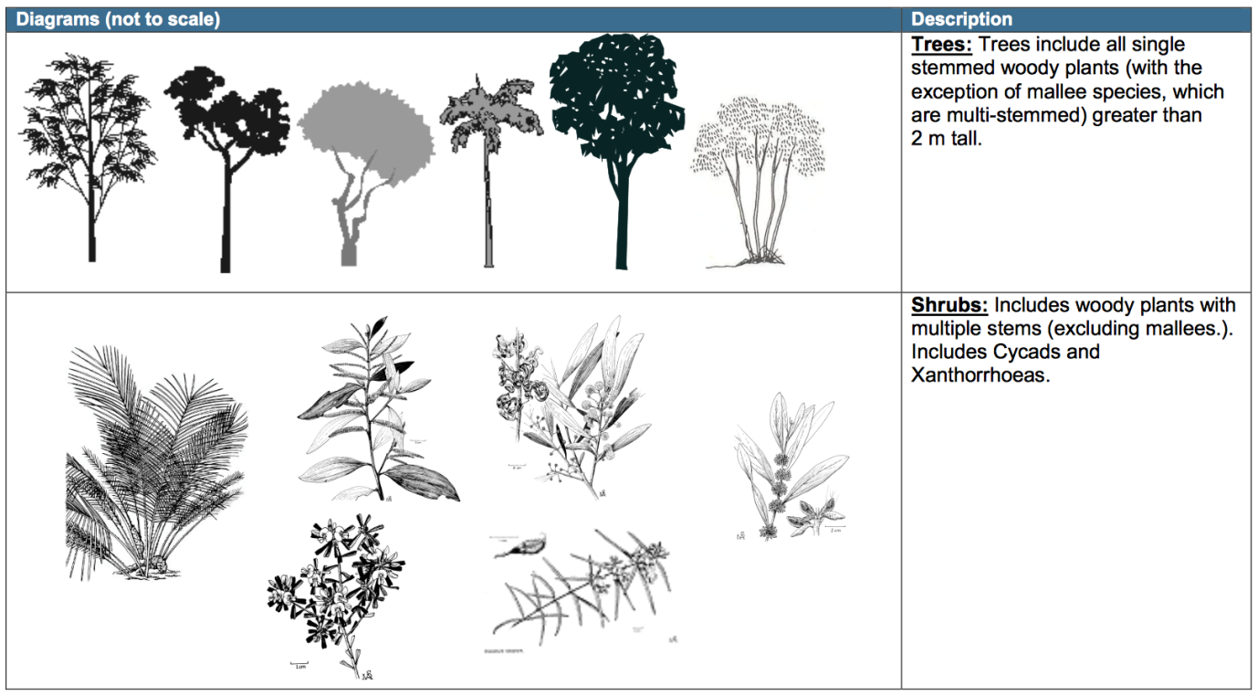

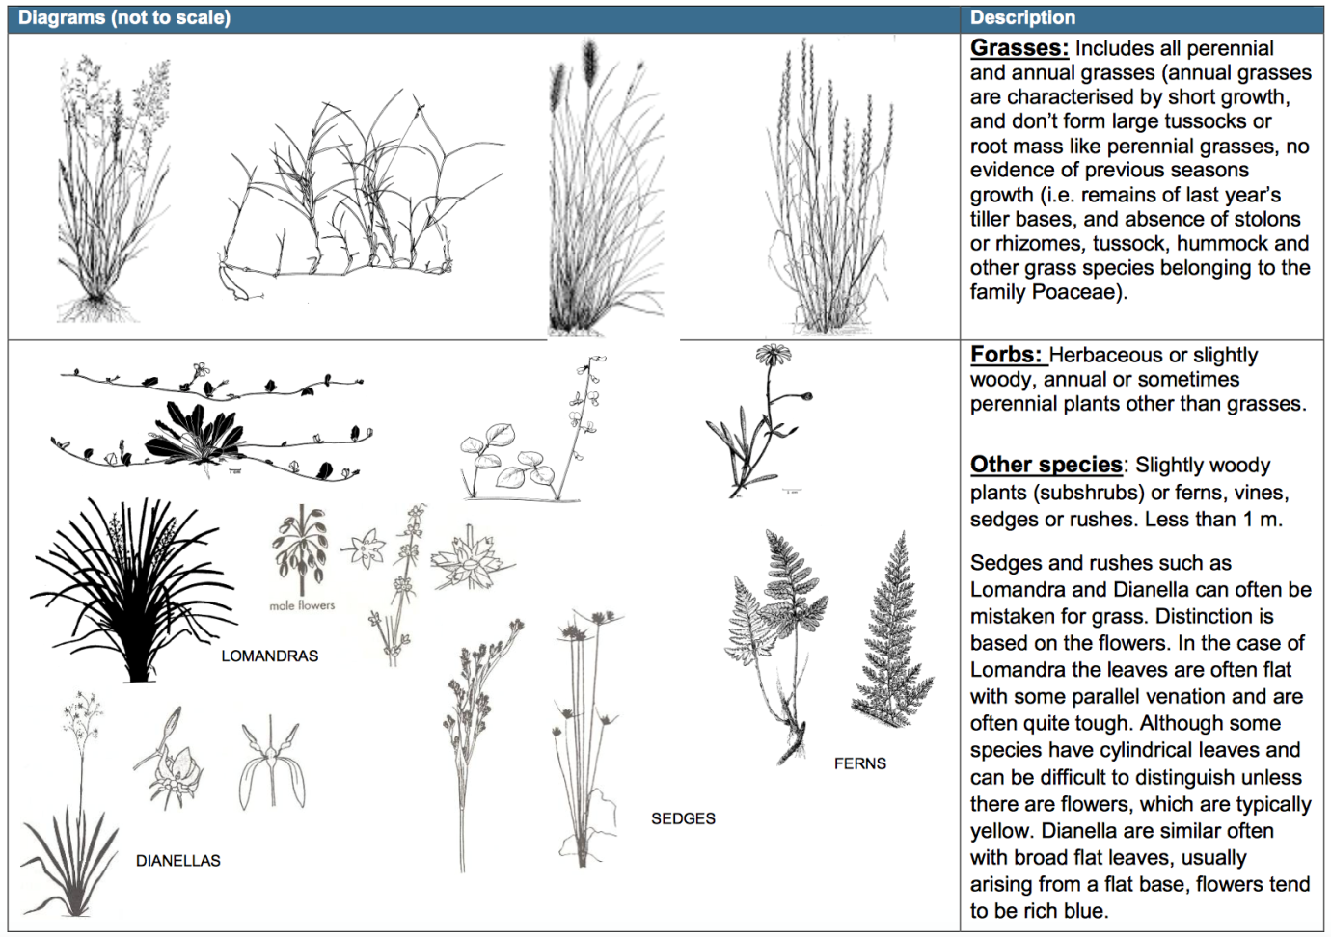

**Appendix C**

**Canopy Cover Estimation Guide**

