**Report on Baseline Ecological Monitoring at Arnwood Place 2015**

**Stephanie Ford**

**Introduction**

Arnwood Place is a project site of Norman Creek Catchment Coordinating Committee (N4C) and a Habitat Brisbane site. It includes a section of the main channel of Norman Creek and a section of Sandy Creek. It has undergone significant changes since European settlement, including large scale clearing, agriculture and industrial use, redirection of Norman Creek, and a major revegetation project in 2001 and 2003.

Arnwood Place has been visited by at least teams of water quality monitors. Brisbane City Council and Environmental Protection Agency did monitoring in July 1999 and June 2000 (Webb 2001; Brisbane City Council 2005). GHD completed monitoring for N4C in August 2013 (GHD 2015). In addition, the site is also part of Healthy Waterways’ Ecosystem Health Monitoring Program (EHMP).

The aim of this report is to provide a summary of the terrestrial ecology of Arnwood Place (AP) based on the Baseline Ecological Monitoring carried out in August and September 2015, answering the following questions:

1. What are the key physical factors of the site?
2. What is the vegetation cover (percentage) and what is the structure of the vegetation?
3. How many exotic species are there compared to native species?
4. How are animals (in this case, birds) using the site and does this correspond to particular physical features or vegetation communities?
5. What threatening processes are occurring at the site and can they be managed?
6. How does the vegetation community compare to the pre-European ecosystem? How could the vegetation be of greater use to animal species and to the health of the waterway?

These questions will be answered by looking at the data from Biocondition, Vegetation and Animal Surveys.

**Method**

AP was divided into six sections (Sections A to F; see figure 1). Notice that Section A contains mown areas only (no trees or shrubs). Data was collected by a team of 6 people on August 2 2015 and a team of 10 people on September 6 2015, by walking around in pairs or small groups and making observations. There was no destructive sampling or trapping of animals. Data includes basic physical features (Baseline Data) general ecological condition (Biocondition), Vegetation and Fauna. Vegetation structure was assessed using the scale of decreasing abundance: dominant, abundant, frequent, occasional or rare. Bird counts were done for the whole site on both observation dates. Sections were combined due to birds’ use of both sides of the creek. Bird data includes calls heard; observers are very experienced and able to identify local species from their calls.

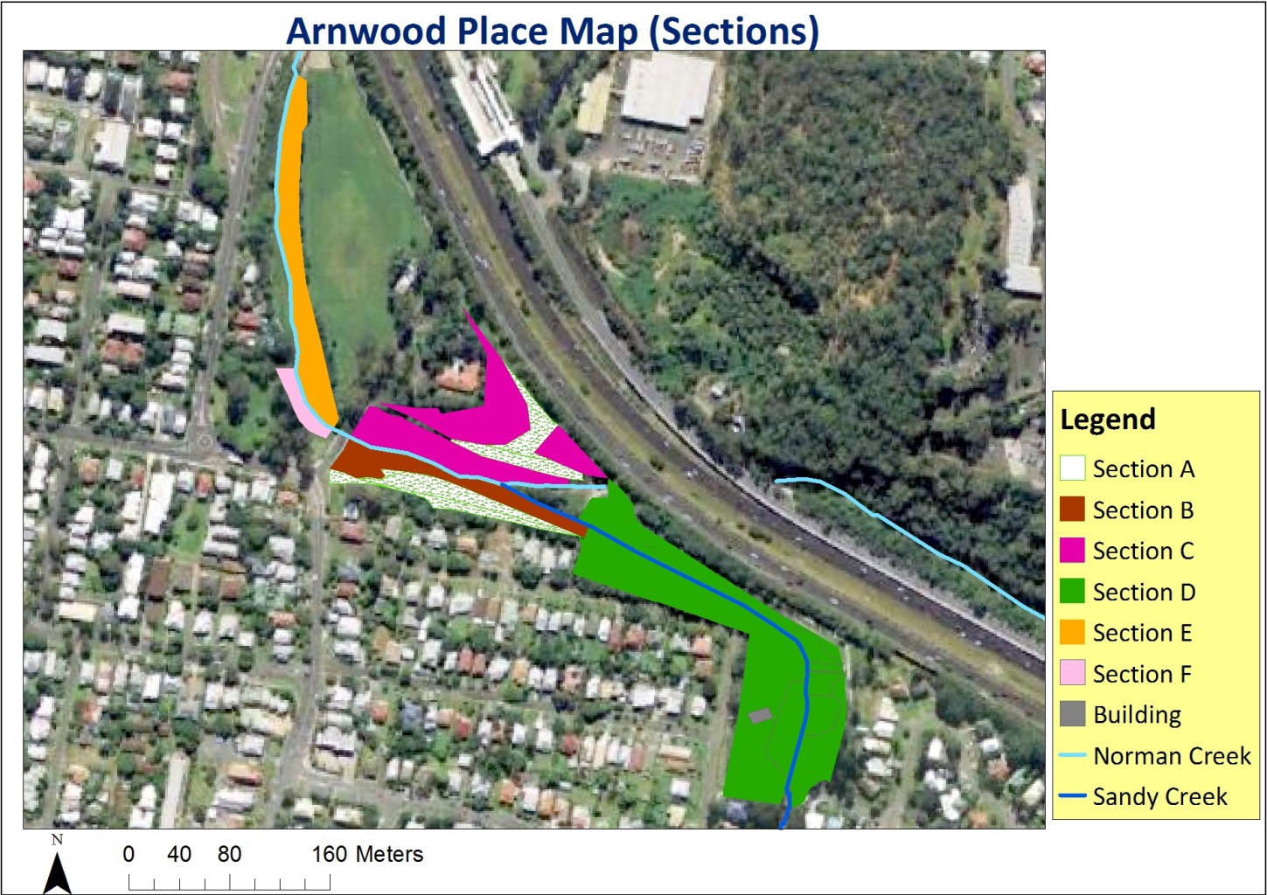

Figure 1. Arnwood Place Habitat Areas, Sections A to F (Prepared by Paulina Lee)

Table 1. Key Baseline Data

|  |  |  |
| --- | --- | --- |
|  | **Arnwood Place (sections A,B,C)** | **Arnwood Place (sections D,E,F)** |
| **DATE and TIME** | 02/08/2015 8 AM | 06/09/2015 8 AM |
| **SLOPE SHAPE** | Banks vary from vertical to 25% slope.  Gentle slope further away from creek.  Sewage riser in bank at one point. | Creek banks vary:  Section E and F: 25% to 90%;  Section D (Sandy Creek): 25% to 50%.  Gentle slope further away from creek. |
| **BANK HEALTH**  **(0 TO 3; POOR to GOOD)** | 1 | 2 in section D;  1 in sections E and F |

**Results**

**Key physical factors**

Some key baseline data describing the site can be viewed in Table 1. It shows fairly poor bank health in many sections of the site. Some banks in sections B, C and E have caved in; all these sections are on the main channel of Norman Creek.

**BioCondition**

The key findings regarding biocondition are the vegetation cover, recruitment, species richness and other habitat resources.

* **Vegetation cover**

The tree cover percentage of sections A to F was 4%, 40%, 70%, 30%, 70% and 50% respectively, which results in an overall tree cover for sections B to F of 52%. Trees were largely absent from section A. There were significant numbers of large trees at Arnwood Place, with 86 Eucalypts larger than 30cm dbh and 165 non-Eucalypts larger than 20 cm dbh. Notably, there were 100 large non-Eucalypts in section E. Additionally the overall tree health of AP was good, rated 4 to 5 in all sections (1 to 5 Dead to Good).

Regarding ground cover, section A was also deficient in terms of species groups, with largely exotic grasses and exotic forbs (“weeds”) providing very limited habitat. Sections B, C and D had the greatest variety of ground and shrub cover, and more native components. They had the highest ratings for shrub cover.

All sections except A had bare ground recorded as “present” but there is not enough detailed data in the field sheets to substantiate the bare state of steep creek banks which were observed on the day.

* **Recruitment of Woody Species (0 to 3: nil to considerable)**

The recruitment of woody species is rated 1 in sections B, D and E, and 0.5 in section C, whereas in sections A and F no naturally occurring seedlings were found.

* **Species Richness**

The species of the site were fairly diverse consisting of native and exotic trees, shrubs, grasses, herbs, a mistletoe, sedges, vines and native ferns. Native trees and exotic herbs were the most diverse plant groups at AP. It is noticeable that section C had the most native trees (61 species) and section B had the most exotic herbs (34 species). Further, sections B and C had the greatest number of native herb (11 and 9) and shrub species (13 and 15). The following table provides an overview of the total number of native and exotic species in each section. Apart from the mown grass in section A, section F had the next largest proportion of exotic species, which include many weeds.

Table 2. An overview of the total number of native and exotic species in each section (Prepared by Paulina Lee)

|  |  |  |  |  |  |  |
| --- | --- | --- | --- | --- | --- | --- |
|  | **Section A** | **Section B** | **Section C** | **Section D** | **Section E** | **Section F** |
| **Total Native Species** | 1 | 71 | 96 | 67 | 57 | 11 |
| **Total Exotic Species** | 21 | 50 | 34 | 50 | 26 | 27 |
| **Total Species in section** | 22 | 121 | 130 | 117 | 83 | 38 |

* **Other Habitat Resources**

Other habitat resources includethe number of fallen logs (larger than 10 cm diameter) and arboreal termite nests. There were 9 large fallen logs with an estimated 10m length in section C. In relation to termite nests, section D had the most (7 out of a total of 10 nests which are in sections C, D and F).

**Vegetation**

* **Structure**

In section A, the dominant species were green couch and broad-leaved paspalum. All species were in the ground layer only, and the only native species was swamp dock (*Rumex brownii*).

Section B had most species (82) in the ground layer, less in the shrub layer, and only 11 species of trees. The most abundant species was guinea grass (*Megathyrsus maximus*). It is a concern that glycine (*Neonotonia wightii*) was a frequent species there, although it had been kept out of the tree layer. The shrub layer there contained mostly native species. The tree canopy was mainly spotted gum (*Corymbia citriodora var variegata*).

Glycine was in all levels of the canopy in Section C, and balloon vine was in the ground and tree layers. Glycine and two ground layer weeds were the only abundant species in this section. This section had 42 species in the tree canopy and this correlates with it having the equal highest canopy cover. *Elaeocarpus grandis* was dominant in the tree layer and *Alphitonia excelsa*, *Araucaria cunninghamii, Diploglottis campbelli, Eucalyptus tereticornis* and *Ficus obliqua* (all native) were frequent tree species. Despite the large number of exotic species, native species were the most abundant in the tree and shrub layer. Chinese elm was present here but only in the ground and shrub layer.

There were 62 species in the ground layer in Section D and a large number were exotic. The shrub layer was more dominated by natives, as was the tree layer (only one exotic here, *Tecoma stans*). Moreton Bay fig was the most abundant tree species, but five species of Eucalypts were frequent.

In section E, the dominant plant was guinea grass; in addition, glycine was abundant and it was in all layers. However, three natives were frequent in the ground layer: *Lomandra longifolia*, *L.hystrix* and *Cissus antarctica*. The shrub layer was a mix of 10 native and 5 exotic species. There were 43 species in the tree layer, all but 5 native, including Chinese elm. A feature of this section is the large camphor laurel tree.

Section F contained a large number of weed species; in the ground layer, all frequent and abundant plants were exotic except for *Persicaria attenuata*. Glycine was frequent and it was in all layers. Balloon vine (*Cardiospermum grandiflorum*) was also frequent. All 11 shrub layer species were exotic. 5 out of 12 tree species were exotic. Nevertheless, there was a canopy due to the fact that some tree specimens were very large.

**Animals**

Numbers of birds seen were higher in sections B, C and D than in sections E and F. On 2 August the number of species was similar, but on 6 September there were twice as many species in sections B,C and D. The additional species on 6 September consisted of some tree-dwellers, some waterbirds and some ground layer birds.

|  |  |  |  |  |  |
| --- | --- | --- | --- | --- | --- |
| **Observation** | **2-Aug-15** | **2-Aug-15** | **2-Aug-15** | **6-Sep-15** | **6-Sep-15** |
| **Sections** | B and C | D | E and F | B, C and D | E and F |
| **No of individual birds seen** | 44 | 61 | 51 | 117 | 54 |
|  | 105 | |
| **No of species seen or heard** | 16 | 10 | 22 | 22 | 11 |
|  | 24 | |

**Discussion**

**Effect of physical factors**

One of the key limiting factors for Arnwood Place is shown in figure 1: the habitat areas consist mainly of long thin fingers of vegetation along the creek banks. This is especially the case for sections E and F, where there is also less nearby vegetation off the site. These factors would probably limit the site’s usefulness to native animals; a comparison with a less elongated patch such as Moorhen Flats would be useful to check this.

The soil types at Arnwood Place have likely influenced the recruitment of native species; the low ratings for this may be due to past soil movement for bridge construction, freeway construction (use of fill) or the natural channel design project itself (moving and storing soil may kill or bury the seed bank).

Abundance of annual plant species was affected by the time of year (early spring); hence the high abundance of weeds like wild turnip and blue top, and low abundance of *Persicaria* species (at a peak in autumn).

**Native plant species**

Presence and abundance of certain plant species can attract particular animals that may be present in adjacent areas. Habitat Brisbane has previously prepared a revegetation plan for Arnwood Place with the following recommendations of Keystone species (Table 2). Of these, *Lophostemon suaveolens* was still absent from the site, and *Melaleuca quinquinervia, Syzygium australe , Eucalyptus siderophloia, Clerodendron floribundum, Melastoma malabathricum, Guioa semiglauca, Notelaea longifolia, Crinum pedunculatum* and *Breynia oblongifolia* were in very low abundance. It would appear that future plantings should focus on these species; however, some N4C members favour a species mix including many more rainforest species, in particular, figs. Nevertheless, many local birds and potential visiting mammals would be able to make good use of the nectar resources that the plants from table 2 would provide. N4C needs to research the Regional Ecosystem Frameworks more thoroughly to assist with this.

Table 2. Keystone species from Arnwood Place Revegetation Plan (Moran, 2013).

|  |  |
| --- | --- |
| Creek Zone | Dry Zone (distance of the width of watercourse) |
| • *Melaleuca quinquenervia*  *• Melaleuca linariifolia*  *• Glochidion ferdinandi*  *• Syzygium australe*  *• Lophostemon suaveolens*  *• Melaleuca viminalis*  *• Ficus coronata*  *• Crinum pedunculatum*  *• Melastoma malabathricum*  *• Adiantum* spp | • *Eucalyptus siderophloia*  *• Eucalyptus tereticornis*  *• Clerodendrum floribundum*  *• Lophostemon confertus*  *• Notelaea longifolia*  *• Guioa semiglauca*  *• Alphitonia excelsa*  *• Dodonaea triquetra*  *• Breynia oblongifolia*  *• Trema tomentosa*  *• Themeda triandra*  *• Dianella* spp  *• Lomandra* spp |

**Vegetation cover and structure**

Vegetation structure (and tree cover) in some sections (sections B and D) partly shows the effect of past tree death due to canopy coverage by vines, in the period when no bushcare group was active on site. Also, the low species richness in section F shows the lack of riparian planting there.

The structure also shows the stages of recent bushcare work such as in section B where there were many species in the ground layer (many more than in the other layers) which included tubestock planted in the previous 4 years.

The large size of some of the Eucalypts that were present shows that the largest of them must be remnant trees; however they are not common in the shrub or ground layers and may need to be planted to continue at the site. The low ratings for native shrub cover suggest that these also need to be planted, and maintained; these are particularly vulnerable to being covered by vines or to competition from weeds.

Presence/Absence ratings for ground cover do not really give a sense of how useful an area is to animals; in some of the planted areas at Arnwood Place, the ground cover species have not become as bushy as desired and there is quite good visibility along the ground for predator animals. Denser plantings of ground covers may be needed, or choosing more bushy ground cover species.

**Creek Erosion**

The main channel of Norman Creek suffers from erosion, and banks sometimes cave in during high-flow events (once or twice a year). However, there is no specific section of the current data sheets to quantify this, apart from the general description on the Baseline sheet and the bare ground presence/absence in the Biocondition sheet. The lower-profile banks in Sandy Creek do not show such severe erosion. More precise measuring of ground cover is needed on creek banks, perhaps with quadrats.

Discussion with Habitat Brisbane officers has yielded recommendations to plant the tops of the banks with appropriate tree species to retain the soil rather than any rock or engineering solution. From discussion with Damien Madden from the original project planning team it appears that the banks in the main channel used to be more gently sloping but that the channel has become deeper and deeper over the past 13 years.

**Weed management**

In some sections such as section B, Guinea grass was very abundant as it had been left as cover for native animals; as adjacent areas become more bushy, it will be able to be cleared. Such cover is important considering the high use of the area by dog walkers (on and off leash), and cats belonging to adjacent residents. Guinea grass is not a major threat to native trees.

Regarding declared weeds, the vines are the most threatening types at Arnwood Place. Balloon vine and madeira vine require constant monitoring to keep them out of the canopy, especially in section C near the childcare centre. Glycine is not a declared weed but it poses as least as big a threat in this site. Chinese elm was overall under control at this site, but continued effort is needed with time to remove the specimens in the shrub layer, and the few from the tree layer in section E. Lantana is not a threat to native vegetation here, and can be left as cover until native replacements are planted. The large camphor laurel is enjoyed and appreciated by local people and its seedlings will need to be removed from surrounding areas. Cat’s claw (*Dolichandra unguis-cati)* was not noted during the ecological monitoring but it was nearby and monitoring is needed by the bushcare group.

**Use of the site by birds**

The greater number of individual birds in sections B, C and D is probably partly a function of the greater area of that part of AP and the higher shrub cover. Further, those parts of the site are wider and have better continuity with nearby vegetation.

The data on bird species show significant variation between observations, meaning that a larger number of observations would give a clearer picture. N4C should download and analyse data from the ebird website to provide this.

At AP, a fair amount of weedy guinea grass (*Megathyrsus maximus*) is left to provide cover for animals, and much of this is in sections B,C and D. The presence of the small ground birds white-browed scrubwren (*Sericornis frontalis)* and superb fairywren (*Malurus cyaneus)* supports this current practice.

AP contains nectar-bearing plants such as Eucalypts and Melaleucas of various sizes and these are utilised by birds, especially honeyeaters. There are a large number of noisy miners *Manorina melanocephala* relative to other species of honeyeaters such as brown honeyeaters *Lichmera indistincta;* it would be good to achieve a higher level of tree cover and shrub cover to enable other honeyeaters to escape from attack by noisy miners.

On these observations no Common Mynas were found; however they have been seen in the surrounding area and it would be good to encourage local residents to join the Common Myna trapping program to ensure they don’t take up nest hollows or consume all local food resources.

**Acknowledgements**

N4C thanks all volunteers who participated in data collection; Lisa Weber, who designed the original field sheets; Paulina Lee, who prepared the maps; and Brisbane City Council for their financial support of the Baseline Ecological Monitoring project. We also thank BCC’s Habitat Brisbane section for supplying resources and training and the HB officers who have advised and supervised our work at Arnwood Place in recent years: Kate Flink, Simon Fox and Andrew Wallace.

**References**

Brisbane City Council. (2005). *Norman Creek: know your creek: improving our waterways from Backyard to Bay*.

GHD. (2015). *Norman Creek catchment ecological assessment: Baseline aquatic ecology*. Report prepared for Norman Creek Catchment Coordinating Committee.

Moran, A. (2013). *Arnwood Place Revegetation Plan*. Prepared for Habitat Brisbane, Brisbane City Council.

Webb, G. (2001). A city-wide assessment of water quality in Brisbane’s creeks. October 1999– April 2000. Waterways Scientific Services. Queensland Environmental Protection Agency.